Sof-Fusion Pressing Pillows

We Use Premium Grade 5 Mil PTFE (Teflon) Fabric. Our Protective outer layer last longer and protects our premium foam inner layer.



1. **Adjust the pressure by turning the pressure adjustment knob on your heat press towards the minus sign (or similar, depending on your model).**



**The next step is important in order to preserve your pillows.**

**2. There should be about a half-inch gap between your heat press top and the top of your garment before lowering press and locking heat press down.**



**Tutorial: How to Use Pressing Pillows in Your Heat Press**

**Heat press users will know that some items are more difficult to press such as infant bodysuits, shirts with pockets, or items with zippers or thick seams.**



**3. Insert the heat press pillow inside the garment to be pressed and pre-press the garment for a few seconds.**

**4. Add your design and press at the necessary time and temperature with a Teflon sheet or parchment paper.**

****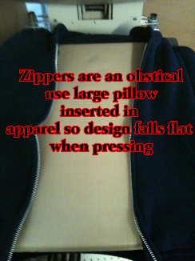

L J Robin Marketing manufactures Sof-Fusion Pillows.